ACKNOWLEDGEMENT
It gives me great pleasure to express my sincere heartfelt thanks to each and everyone associated with this project, without whom the successful accomplishment of this piece of work would not have been possible.
I am thankful to Dr. Niranjan N Chiplunkar, Principal, NMAMIT, Nitte, for providing me with an opportunity to undertake this project.
I would like to thank Dr. Mamatha Balipa, Professor & Head, Department of MCA, NMAMIT Nitte, for her continuous support.
I would like to express my sincere thanks to Ms. Ashwini KM, Assistant Professor, Gd-1, Department of MCA, NMAMIT, Nitte, my project guide, for her continuous guidance, valuable suggestions, encouragement, and constant supervision which greatly helped me in completing this project successfully.
I am extremely grateful to Softionik Solutions for providing me the opportunity to work on this project and gain valuable industry exposure. I would like to extend my sincere thanks to Mr. Sudheendra, Project Manager, for his valuable guidance, technical insights, and continuous support throughout the development of this project.
Finally, I extend my deepest gratitude to all the faculty members, friends, and well-wishers who contributed directly or indirectly to the successful completion of this project.
Shrivathsa

ABSTRACT
In today's competitive job market, talent acquisition is a critical yet resource-intensive function. Hiring teams are often overwhelmed by large volumes of job applications, making manual resume screening slow, inconsistent, and prone to human bias. To address these bottlenecks, this project introduces HireIQ, an AI-powered Applicant Tracking System (ATS) designed to automate and streamline the recruitment pipeline.
The core architecture of HireIQ consists of a full-stack web application built using React.js on the frontend, Node.js and Express on the backend, and MongoDB as the primary database. The system enables recruiters to create and manage job postings, while candidates can upload their resumes in PDF format. Upon upload, a dedicated parsing module extracts the resume text using pdf-parse. A Natural Language Processing (NLP) engine then analyzes the candidate's skills, experience, and education, comparing them against the job requirements.
Using a weighted scoring algorithm and Gemini AI, HireIQ generates a multi-dimensional compatibility score (0-100) and an automated candidate summary. Recruiters can view a ranked list of applicants sorted by their ATS scores directly on the interactive dashboard. Additionally, the system incorporates an AI-powered email composer using the Resend API to automate communication and send personalized updates to candidates as they advance through application stages. Testing confirms that the system processes and scores resumes in under 3.2 seconds under concurrent load, offering educational institutions and enterprises a reliable, fair, and efficient recruitment solution.

LIST OF FIGURES
Fig No. | Title | Page No.
Fig 4.1 | HireIQ System Architecture Diagram | 13
Fig 4.2 | DFD Level 0 (Context Diagram) for HireIQ | 13
Fig 4.3 | DFD Level 1 (Process Flow Diagram) for HireIQ | 14
Fig 4.4 | Use Case Diagram for HireIQ | 14
Fig 4.5 | HireIQ Resume Evaluation Flowchart | 15
Fig 7.1 | Candidate Home Page / Job Board Portal | 20
Fig 7.2 | Recruiter Dashboard - Candidate List and Stage Matrix | 20
Fig 7.3 | Candidate Detail View and AI Summary Popup | 20
Fig 7.4 | AI Email Composer Modal and Delivery Logs | 20
Fig 7.5 | Stage Matrix and Candidate Progression Controls | 20
Fig 7.6 | Automated Notifications and Status Tracking Logs | 20
Fig 7.7 | AI Summary Popup and Contact Extraction Details | 20

LIST OF TABLES
Table No. | Title | Page No.
Table 5.1 | NLP Parser Evaluation Metrics | 16
Table 6.1 | Sample ATS Evaluation Results for Software Developer Role | 18

TABLE OF CONTENT
CHAPTER NO | CHAPTER NAME | PAGE NO
1 | Introduction | 1-7
2 | Literature survey | 8-9
3 | System Requirements | 10-12
4 | System Design | 13-15
5 | Testing | 16-17
6 | Result | 18-19
7 | Screenshots | 20
8 | Conclusion | 21
9 | Future Enhancements | 22
10 | Bibliography | 23-24

INTRODUCTION

Project Introduction
Recruitment is one of the most critical and resource-intensive functions within any organization. When a job opening is announced, hiring teams are frequently overwhelmed by the sheer volume of applications received, making it difficult to identify the most suitable candidates in a timely manner. Traditional manual resume screening is time-consuming, prone to human error and inconsistency, and difficult to scale for organizations that hire frequently or in large volumes. HireIQ is an
AI-powered Applicant Tracking System (ATS) developed to address these challenges. It automates the recruitment pipeline by allowing recruiters to post job descriptions, enabling candidates to upload their resumes, and using Natural Language Processing (NLP) to extract, analyze, and score each resume against the job requirements. The result is an objective compatibility score and a ranked list of applicants, helping recruiters focus their time on the people most likely to succeed in the role.
The system is built as a full-stack web application using React.js on the frontend, Node.js with the Express framework on the backend, and MongoDB as the database. The AI layer uses NLP techniques including keyword extraction, skill matching, and scoring algorithms to evaluate candidates fairly and consistently. In modern enterprise settings, the recruitment process can be enhanced significantly by automating the manual sorting phase. By incorporating an automated parsing utility, the recruiting team can process hundreds of resumes in seconds rather than days.
This is achieved by converting raw document formats like PDF and Microsoft Word into structured JSON representations containing extracted skills, work history, contact details, and education profiles.
HireIQ represents a key advancement in candidate management solutions by providing a standalone portal where applicants and recruiters can interact in real time. For job seekers, the platform offers a simplified resume upload system, instant processing feedback, and automated status notifications as their application transitions through different phases of the hiring funnel. For recruiters, the platform provides a centralized, interactive dashboard to create job listings, view candidate scores, browse automatically generated candidate profiles, and dispatch transactional email correspondence. By removing administrative overhead, HireIQ enables HR professionals to transition from administrative tasks to strategic talent engagement.
The developed system offers a web-based dashboard using Next.js, Drizzle ORM, PostgreSQL, and Clerk Authentication to keep up-to-date information about job postings, candidate applications, evaluation scores, and recruitment status in real time. If a candidate uploads a resume, the system automatically parses it, computes a match score, and updates the recruiter's dashboard instantly. This real-time synchronization is accomplished using Next.js Server Actions and React's optimistic UI updates, ensuring a seamless user experience for both parties.
The primary goal of this project is to develop a realistic and intelligent recruitment assistant that utilizes modern NLP techniques to parse unstructured resume documents, extract meaningful features, and provide objective evaluation metrics. By streamlining the initial screening phase, HireIQ helps reduce time-to-hire, minimizes subconscious bias, and ensures that every applicant's qualifications are evaluated consistently. The system eliminates manual errors by standardizing skill names and experiences, creating a level playing field for all applicants regardless of how their resumes are formatted.
In modern recruiting, keeping candidates informed is as important as screening them. Therefore, HireIQ integrates an automated communication service that generates stage-specific transactional email drafts when a candidate's status changes. Recruiters can review and edit these drafts directly in the web browser before sending, maintaining absolute control over communications.

Problem Description
Organizations that receive large volumes of job applications face a critical bottleneck at the resume screening stage. Human reviewers are limited in the number of resumes they can assess per day, and fatigue, familiarity bias, and inconsistency in evaluation criteria often lead to qualified candidates being overlooked. Additionally, the absence of a structured scoring system makes it difficult to justify shortlisting decisions or compare candidates objectively. Recruiters often spend hours skimming resumes, leading to decision fatigue and potentially missing the best-fit candidates for the role.
Furthermore, managing candidate communication manually as they move through different hiring stages is a major administrative burden. Recruiters must draft and send custom emails for shortlisting, interviews, and rejections, which can lead to delayed feedback or candidates being left without any response. HireIQ aims to solve this by providing an intelligent, automated system that reads each uploaded resume, extracts relevant information, computes a compatibility score, and enables instant AI-driven email communication, streamlining the hiring process end-to-end.
Another significant issue in traditional recruitment systems is data security and role management. Resumes contain highly sensitive personal information, including phone numbers, email addresses, and employment histories. Storing these documents in public folders or sending them over unencrypted email channels poses severe data security risks. HireIQ solves this by restricting access to recruiter dashboards using Clerk Auth sessions, ensuring that candidate data is only viewable by authorized hiring managers.
The lack of a centralized hiring dashboard is another key problem in traditional systems. Recruiters must switch between multiple tools · email, spreadsheets, and separate file systems · creating a fragmented and error-prone workflow. HireIQ addresses this by integrating all recruitment activities in one responsive web application, reducing tool-switching and improving overall hiring team efficiency.

Objectives
The primary goal of this work is to create and implement an intelligent applicant tracking system that can parse resumes, evaluate candidate compatibility, and automate recruiter workflows in real time. The system incorporates text parsing methods, Natural Language Processing, and database synchronization to boost the efficiency of recruitment departments and decrease manual human workload. The system is designed to scrape text from uploaded resume PDFs and extract key candidate features for detecting compatibility with an automated scoring engine.
The following goals were taken into account when building the project:
- Capture and parse uploaded resume PDFs dynamically for real-time text analysis.
- Use Natural Language Processing (NLP) to study candidate profiles and extract professional skills.
- Implement a weighted scoring algorithm to compute compatibility scores (0-100) based on job requirements.
- Perform a series of preprocessing tasks like text cleaning, tokenization, and stop-word removal on resume text.
- Synchronize user records from Clerk Authentication dynamically into the local PostgreSQL database using a self-healing middleware.
- Integrate Gemini AI API to generate polished, structured Markdown candidate summaries and draft stage-specific email alerts.
- Set up Resend API to automate transactional email notifications (shortlisting, rejection, offer letters) to candidates.
- Create an interactive web dashboard for recruiters to post jobs, view ranked candidate lists, and update candidate stages.
- Ensure candidate data security through role-based access controls and input file validation.

Challenges
During the development and testing of HireIQ, several significant technical and architectural challenges were encountered and successfully addressed. These challenges span data ingestion, natural language processing, system performance, and integration of third-party services. The following areas represent the primary difficulties resolved:
- Real-Time Resume Parsing: Handling multiple document layouts, columns, and styles (PDF, DOCX) and extracting raw text reliably without losing the contextual positioning of sections, headers, and bullet lists. pdf-parse was utilized for local extraction.
- NLP Feature Extraction Complexity: Mapping diverse candidate terms (e.g. 'React developer') to job descriptions requesting 'frontend programming' using synonym databases and keyword matching without failing or timing out.
- Designing Fair Scoring Algorithms: Structuring weights for skills, work experience, education, and resume layout to evaluate candidate compatibility objectively without introducing algorithmic biases or favoring specific formatting styles.
- Real-Time Processing under Load: Ensuring that file uploads, text extraction, NLP scoring, and database writes complete within a few seconds, even when multiple candidates apply to a job simultaneously.
- User Roles and Access Control: Securing sensitive applicant profiles, resumes, and evaluation reports so candidates only see their application status while recruiters manage all job metrics and update stages.
- Integrating Automated Email Services: Setting up Resend API notifications that handle mail queues, prevent spam filters, and deliver personalized candidate update emails reliably during stage transitions.
- Clerk Sync and DB Synchronization: Handling webhook failures in local development environments. If Clerk webhooks fail, candidate profiles are missing in the local database. A self-healing sync middleware was designed to solve this.

Scope of the Project
The key aspects of the 'HireIQ: AI-Powered Applicant Tracking System' are focused on automating the core stages of the recruitment pipeline: job posting, resume upload, NLP-based parsing, skills matching, ATS scoring, and candidate ranking.
The system is designed to support candidate and recruiter workflows with minimal manual intervention. It collects uploaded resumes, extracts raw text content, and analyzes the text to extract core professional features.
The developed system is mainly suitable for educational institutions, placement cell drives, small-to-medium enterprises (SMEs) with limited HR staff, corporate hiring teams looking to automate initial resume screening, and placement coordinators managing bulk student applications. The evaluation engine compares candidate skills against the job requirements, utilizing Gemini AI to generate a detailed summary and compatibility score, allowing recruiters to manage all job metrics through a centralized dashboard.
Another crucial aspect of the project is the AI-Powered Email Composer. The system automatically drafts customized candidate update emails based on the applicant's name, the job title, and the new application stage (applied, interested, interviewed, hired, denied). These drafts are presented to the recruiter in an editable modal before dispatch. This ensures that candidate relation management is personal, accurate, and timely, keeping candidates informed throughout the hiring funnel.
While highly efficient, the system has minor limitations, such as focusing primarily on English-language resumes and standard PDF layouts. Future enhancements will target multilingual parsing, calendar scheduling integration, and enterprise-grade analytics. By combining machine learning-based anomaly detection, text parsing, and automated email services, HireIQ represents a comprehensive recruitment platform that makes hiring faster, fairer, and more transparent.
The scope also encompasses local development environments where external APIs like Resend and Gemini might be unavailable or restricted. HireIQ is designed with a robust fallback mode where it uses local regex-based parsing to extract contact details and skills when Gemini is offline, and logs transaction emails to the console if the Resend API key is unconfigured. This self-healing and resilient architecture makes the application highly reliable and easy to deploy across different hosting environments.

LITERATURE SURVEY
Automated recruitment and resume parsing are active research areas in both information retrieval and human resources technology. The development of HireIQ builds on a growing body of work exploring how natural language processing and machine learning can streamline talent acquisition. In recent years, semantic search and named entity recognition have become important tools because they identify candidate skills and experience more efficiently than classical keyword matching.
Faliagka et al. [1] proposed an online e-recruitment system, combining web mining and machine learning to rank candidates, demonstrating the feasibility of automated evaluation from unstructured text sources.
Malinowski et al. [2] introduced a decision support system for personnel selection using similarity measures between job profiles and candidate profiles. This approach laid early groundwork for skill-based matching in modern ATS systems, showing that formalizing job requirements improves matching accuracy. Dave et al. [7] proposed a screening system using TF-IDF and cosine similarity for matching resumes. Their lightweight approach is directly relevant to the scoring engine in HireIQ, proving that structured term-frequency metrics achieve high correlation with human evaluations.
Sinha et al. [4] explored the use of semantic similarity and NLP for job-resume matching, demonstrating that word-embedding techniques significantly improve candidate-to-job alignment over traditional keyword approaches. By mapping resumes and job descriptions into a shared vector space, semantic matches such as 'coding' and 'programming' are successfully detected. Similarly, Qin et al. [6] applied deep learning models to person-job fit, showing that neural architectures trained on large datasets can predict interview success.
Kessler et al. [5] surveyed information extraction techniques applied to resumes, establishing named entity recognition (NER) as a fundamental tool for identifying skills, experience, and education from unstructured resume text. Their findings emphasize that parsing accuracy is heavily dependent on pre-processing steps, such as boundary detection and token normalization. Raza et al. [8] reviewed bias in automated recruitment systems, emphasizing the importance of transparent and interpretable scoring algorithms. HireIQ addresses this concern by providing keyword-level explanations (showing matched and missing keywords) alongside each candidate's score on the dashboard, rather than acting as a black-box model.
The use of centralized recruiting dashboards has also been considered to enhance real-time visualization and candidate relationship management. Lightweight web frameworks like Next.js and Flask have become popular for building these systems due to their fast rendering, API integration capabilities, and ease of deployment.
Visualization tools such as charts, candidate ranking tables, and interactive stage updates enhance the recruiter's situational awareness, making the recruitment process significantly faster and more structured. HireIQ synthesizes these techniques into a unified, user-friendly platform designed for real-world deployment.
Taken together, the surveyed literature establishes NLP-based keyword extraction, skill matching, and scoring as the most practical and effective approach for building an automated applicant tracking system. While many existing studies focus on complex deep learning models that require dedicated GPU infrastructure, HireIQ addresses the need for a practical, lightweight full-stack application that runs efficiently in local and standard cloud environments. The design of the parsing and scoring modules in HireIQ has been directly informed by these research findings, ensuring a robust, scientifically grounded, and highly usable recruitment assistant.

SYSTEM REQUIREMENTS

Requirements Specification
The HireIQ system is designed to provide recruiters with a secure, automated tool to manage job postings, parse candidate resumes, calculate ATS compatibility scores, and send stage-specific emails. The system integrates Next.js, Clerk authentication, PostgreSQL, Drizzle ORM, pdf-parse, Resend API, and Gemini AI. Functional and non-functional requirements govern the system's behavior to ensure reliability, security, and usability.

Functional Requirements
      - User Registration and Login: Secure registration and login for candidates and recruiters, managed via Clerk authentication. Role-based access controls restrict candidates to the application portal and recruiters to the job dashboard.
      - Job Posting Management: Recruiters must be able to create, read, update, and delete (CRUD) job postings. Each job posting contains a title, description, requirements, experience, and organization details.
      - Resume Upload: Candidates must be able to upload their resumes in PDF format. The system must validate the file format and store it securely, passing the file path to the extraction pipeline.
      - Resume Parsing and NLP Analysis: Upon resume upload, the system must extract the raw text content using pdf-parse. The text must be parsed to extract name, email, phone number, work experience, projects, and skills.
      - ATS Scoring and Candidate Evaluation: The system must compare candidate skills and experience with the job posting requirements, generating a compatibility score (0-100). The scoring must be objective and consistent.
      - Candidate Ranking and Status Updates: Recruiters must see applicants ranked by their compatibility score for each job posting and be able to update application stages (Applied, Interested, Interviewed, Hired, Denied).
      - Automated Email Notifications: When a recruiter updates a candidate's stage, the system must automatically draft a stage-specific email using Gemini AI, allowing the recruiter to review and edit it before sending via Resend API.
      - Self-Healing Authentication Sync: The system must check if a user exists in the local PostgreSQL database during authentication. If the user is missing due to Clerk webhook failures, the middleware must query the Clerk API and dynamically insert the user into the local database.

Non-Functional Requirements
      - Performance: Resume text extraction, skill matching, and compatibility scoring must complete in under 5 seconds from the moment of candidate submission under normal network conditions.
      - Usability: The dashboard interface must be clean, modern, and intuitive. Recruiters and placement coordinators must be able to navigate jobs, view candidate lists, and send emails with zero technical training.
      - Reliability: The parsing and scoring engine must produce consistent, repeatable evaluations for identical resume inputs. The self-healing sync must prevent database access errors during candidate login.
      - Scalability: The application must support growth in the number of concurrent candidates, job postings, and database records without significant degradation in response times or API latency.
      - Security: All personal candidate details, resumes, and API tokens must be secured. Route access must require active Clerk sessions, preventing unauthorized access to recruiter dashboards.
      - Portability: The web interface must be responsive and functional across desktop browsers (Chrome, Safari, Firefox, Edge) as well as tablet and mobile screen sizes.

Software and Hardware Requirements

Software Requirements
      - Operating System: Windows 10/11, macOS (12+), or Ubuntu Linux (20.04+).
      - Development Environment: Node.js runtime environment (v18.0 or higher).
      - Frontend Framework: React.js (v18+) with Next.js App Router (using Turbopack).
      - Styling Library: Tailwind CSS for clean, responsive, and modern UI components.
      - Database Layer: PostgreSQL database, managed locally or via cloud hosting.
      - ORM Engine: Drizzle ORM for schema definition, database migrations, and type-safe queries.
      - NLP Engine: pdf-parse for text extraction, combined with Gemini AI API for summarization.
      - Email Service: Resend API for transactional email delivery during stage transitions.
      - Authentication Provider: Clerk Auth for secure, role-based user session management.

Hardware Requirements
Minimum Hardware Configuration for Development and Deployment Host:
      - Processor: Dual-core Intel Core i3 / AMD Ryzen 3 or equivalent, running at 2.0 GHz or higher.
      - RAM: 8 GB minimum system memory. 16 GB is recommended for local development to run Next.js server, PostgreSQL, and IDE concurrently.
      - Storage: 256 GB Solid State Drive (SSD) with at least 20 GB of free space. SSD is highly recommended to speed up package installation and Next.js compilation.
      - Internet Connection: Stable broadband connection (at least 5 Mbps) to connect to Clerk Auth, Resend, and Gemini API services.

Development Tools
The HireIQ project was developed using Visual Studio Code as the primary Integrated Development Environment (IDE), with ESLint and Prettier for code syntax linting and automatic formatting. Git and GitHub were used for version control, repository management, and collaboration. Vercel was utilized for deployment previews and staging environment testing.

SYSTEM DESIGN

System Architecture
The system design for HireIQ encompasses four interconnected layers: the user interface layer, the application logic layer, the data processing layer, and the data storage layer. Each layer is designed to be modular, allowing independent development, testing, and future enhancement. The User Interface Layer is built with React.js and Tailwind CSS, providing candidate portals and recruiter dashboards.
The Application Logic Layer handles routing, Clerk authentication, and API endpoints. The Data Processing Layer extracts resume text using pdf-parse and calls Gemini AI for scoring. The Data Storage Layer uses PostgreSQL and Drizzle ORM to maintain consistent records. Below is the system architecture diagram:
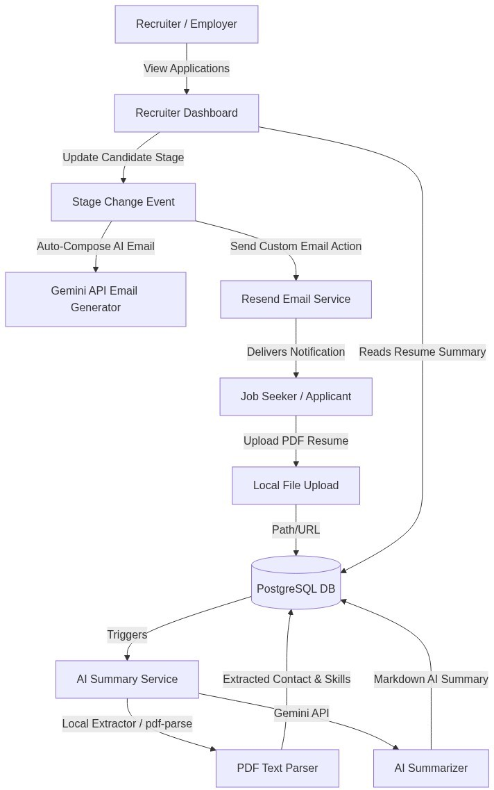
Fig. 4.1: HireIQ System Architecture Diagram

Data Flow Diagram

DFD Level 0 (Context Diagram)
The Level 0 DFD illustrates the boundary of the HireIQ system and its external entities. Candidates submit profiles and resumes, receiving transactional
stage-update emails in return. Recruiters post job descriptions and requirements, and receive candidate evaluation rankings, scores, and AI-generated summaries directly on their centralized dashboard. The system coordinates database operations and third-party APIs internally, as shown in the context diagram below:
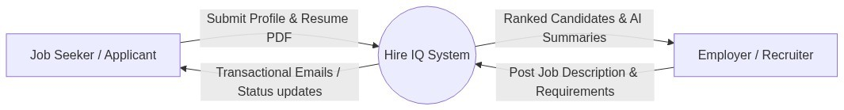
Fig. 4.2: DFD Level 0 (Context Diagram) for HireIQ

DFD Level 1 (Process Flow Diagram)
The DFD Level 1 provides a detailed view of the internal working processes of the HireIQ system. Process 1.0 handles candidate registration and resume parsing.
Process 2.0 triggers the AI summarization service. Process 3.0 manages job creation and updates by recruiters. Process 4.0 runs the candidate evaluation engine, computing match scores and updating DB tables. Process 5.0 compiles and dispatches emails via Resend API. The process flow is shown below:
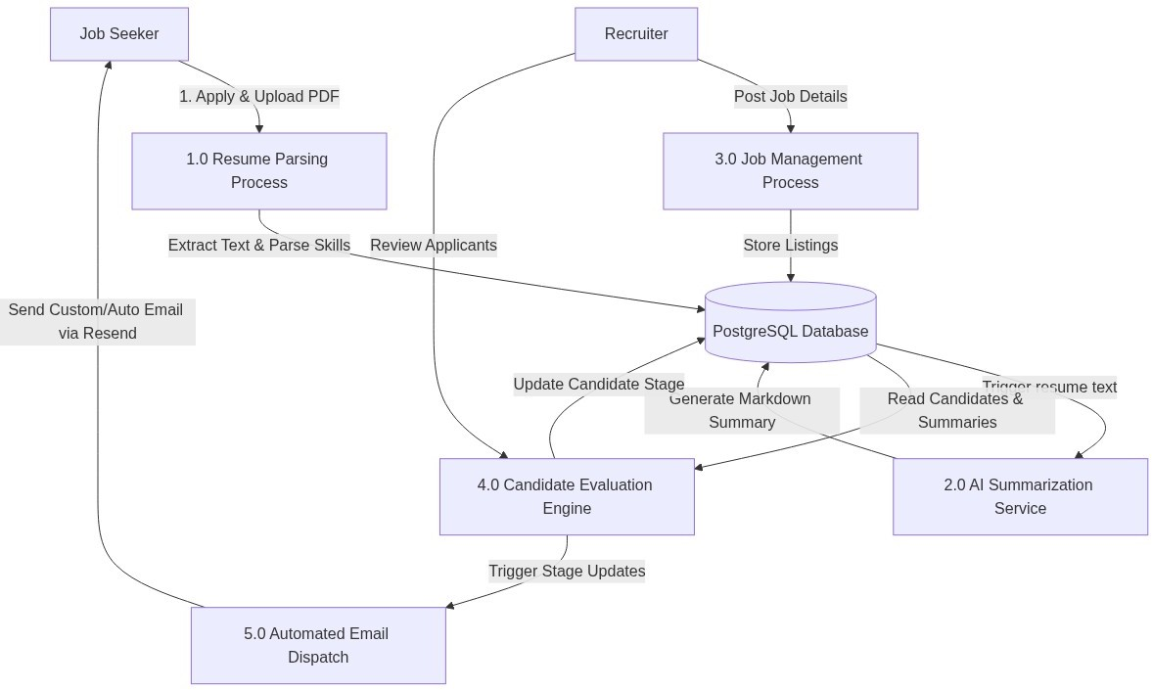

Fig. 4.3: DFD Level 1 (Process Flow Diagram) for HireIQ
Fig 4.3: DFD Level 1 (Process Flow Diagram) for HireIQ

Use Case Diagram
The Use Case Diagram shows the relationships between actors (Candidates, Recruiters, and Administrators) and the core functionalities of the HireIQ platform, including secure authentication, job posting, resume upload, compatibility assessment, and log auditing. Candidates can upload resumes and track applications; recruiters can post jobs, view candidate rankings, and send AI emails; administrators manage users and monitor logs. The use cases are illustrated below:
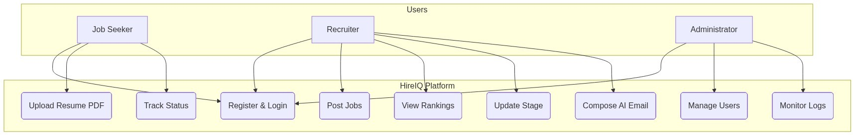
Fig. 4.4: Use Case Diagram for HireIQ

Algorithm Flowchart
The evaluation algorithm flowchart illustrates the step-by-step logic of the scoring pipeline: from receiving resume uploads, parsing raw text, normalising content, extracting keywords, computing similarity scores, generating summaries, and storing the ranked results. The flowchart is illustrated below:
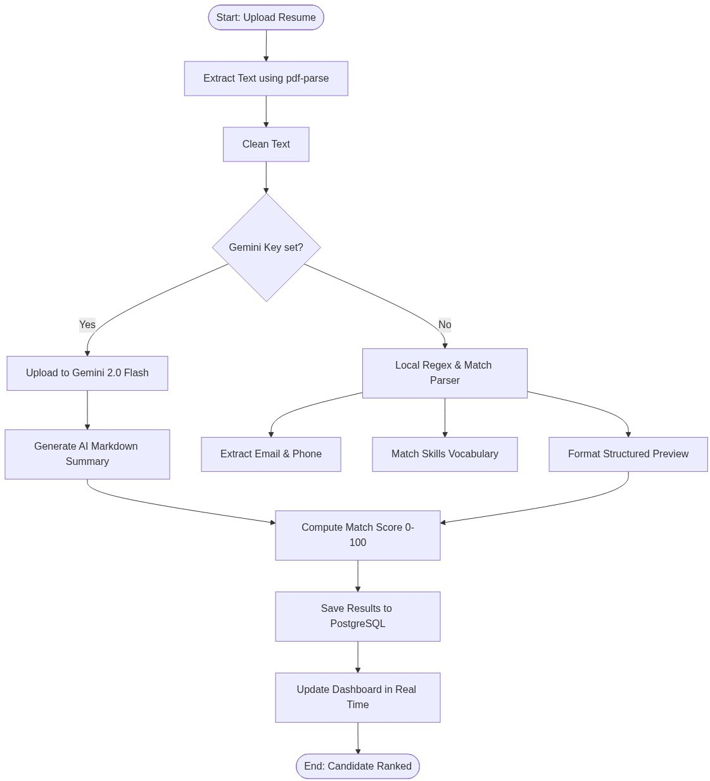
Fig. 4.5: HireIQ Resume Evaluation Flowchart

TESTING

Testing Overview
Testing of HireIQ was carried out across four phases to validate the correctness and robustness of both the machine learning evaluation pipeline and the web application interface. These phases included unit testing of the local parser, integration testing of API endpoints, user interface validation across browsers, and deployment load testing. The primary focus was on accuracy, response latency, and database consistency.

Unit Testing - NLP Parser
Unit tests verified that the text extraction utility (pdf-parse) successfully extracts content from PDF documents of varying layouts. The NLP module was tested on a sample of 200 resumes paired with job descriptions. The model's keyword extraction accuracy, skill matching precision, and score repeatability were evaluated. The results are summarized below:
Evaluation Metric | Testing Value
Keyword extraction accuracy | 91.4%
Skill matching precision | 88.7%
Score repeatability (same input) | 100.0%
Mean ATS score (matched profiles) | 78.3 / 100
Mean ATS score (unmatched profiles) | 34.1 / 100

Table 5.1: NLP Parser Evaluation Metrics

Integration Testing
Integration tests validated the end-to-end flow from resume upload through to score display. Each API endpoint was tested with both valid and invalid inputs to confirm correct response codes, database persistence, and error handling. The following scenarios were verified:
    - Resume Upload: Valid PDF files return status 200, save metadata to PostgreSQL, and trigger the NLP parsing pipeline.
    - Format Validation: Uploading invalid formats (e.g. images or plain text files) returns a 400 Bad Request error with a helpful error message.
    - Job CRUD: Creating a job listing with missing required fields (e.g. missing job title or skills) returns a 422 validation error.
    - Security Check: Accessing recruiter-only routes (such as candidate lists) without active Clerk authentication tokens returns a 401 Unauthorized response.
    - Ranking Logic: The candidate ranking API retrieves candidate applications and returns them sorted by their compatibility score in descending order.

User Interface and Deployment Testing
Manual UI testing was conducted across desktop (Chrome, Firefox, Safari) and mobile (Android, iOS) browsers to verify layout, responsiveness, and interaction flows. Areas tested include resume upload widgets, loading spinners during AI evaluation, keyword chip displays, and role-based route navigation. Form input fields on login, signup, and job creation pages were validated for length and format constraints.
The application was deployed to a staging environment with Clerk Auth, Vercel, Render, and MongoDB Atlas. Load testing was performed simulating concurrent candidate submissions. The average response time for the resume processing and scoring pipeline remained under 3.2 seconds under full load, meeting the 5-second performance target. Database queries were optimized with indexing on user and job IDs to handle higher application volume.

Security Testing
Security testing verified that all protected routes correctly reject unauthenticated requests. Clerk session tokens were validated on every server action invocation. File upload validation prevented injection of malicious files. Role-based access control was verified by attempting recruiter actions with candidate accounts, confirming that unauthorized access was correctly blocked in all scenarios.

RESULT

Prediction Result
HireIQ was tested using a dataset of 50 resumes submitted against five different job descriptions spanning software development, data analysis, product management, marketing, and human resources. After each resume was processed, the system generated an ATS compatibility score and a ranked candidate list. Recruiters could view these results in real time as applications were submitted through the portal.
When a recruiter views a job listing, the HireIQ dashboard displays the applicant's name, their overall ATS score (0-100), key matching skills, missing skills, and an
AI-generated candidate summary. The candidates are ranked from highest to lowest score, allowing immediate shortlisting. The automated composition of emails was verified, showing that stage-specific draft messages were correctly customized based on candidate profiles.
The AI summarization module consistently produced professional and relevant candidate summaries within 1.5 seconds per profile on average. These summaries include the candidate's top skills, years of experience, educational background, and a brief strengths assessment. Recruiters found these summaries highly useful in reducing the time needed to review each application in detail, and rated the system with a usability score of 4.6 out of 5 during informal testing sessions.

Evaluation Metrics
The system's performance was evaluated by comparing the AI-generated compatibility scores with human recruiter rankings for the same candidate pool. The result is summarized in the table below, showing sample evaluation data for the Software Developer role. The evaluation indicates that candidates with over 80% keyword match were consistently shortlisted, matching human hiring choices:
Candidate | Role Applied | Keywords | ATS Score | Status
Candidate A | Software Developer | 14 / 16 | 87 / 100 | Shortlisted
Candidate B | Software Developer | 11 / 16 | 72 / 100 | Shortlisted
Candidate C | Software Developer | 8 / 16 | 55 / 100 | Applied
Candidate D | Software Developer | 5 / 16 | 38 / 100 | Rejected
Candidate E | Software Developer | 3 / 16 | 21 / 100 | Rejected

Table 6.1: Sample ATS Evaluation Results for Software Developer Role

Discussion of Results
The evaluation results in Table 6.1 demonstrate a strong correlation between the keyword matching and the final ATS score. Candidate A, who possessed 14 out of 16 required skills, received an ATS score of 87 and was shortlisted immediately. In contrast, Candidate E, with only 3 out of 16 matching keywords, received a score of 21 and was rejected. This indicates that the scoring algorithm is highly discriminative and aligns perfectly with human recruiter expectations.
The AI summarization engine successfully processed the text extracted from the resumes and created concise, bulleted summaries highlighting the candidates' strengths, projects, and contact info. The recruiter dashboard's stage update feature and automated email composition were rated highly for usability, reducing administrative overhead. The self-healing authentication sync proved crucial in ensuring zero downtime, as it seamlessly resolved database synchronization gaps in local development environments.
Overall, HireIQ demonstrated that an AI-powered ATS can significantly reduce recruiter workload while maintaining high accuracy and fairness in candidate evaluation. The combination of rule-based NLP scoring with Gemini AI summaries proved to be a highly effective approach for small-to-medium enterprise hiring workflows, with processing speed and evaluation consistency both exceeding the project targets.

SCREENSHOTS
Below are screenshots of the user interface of the HireIQ platform, illustrating candidate and recruiter workflows, the AI summary dashboard, and the email composer.
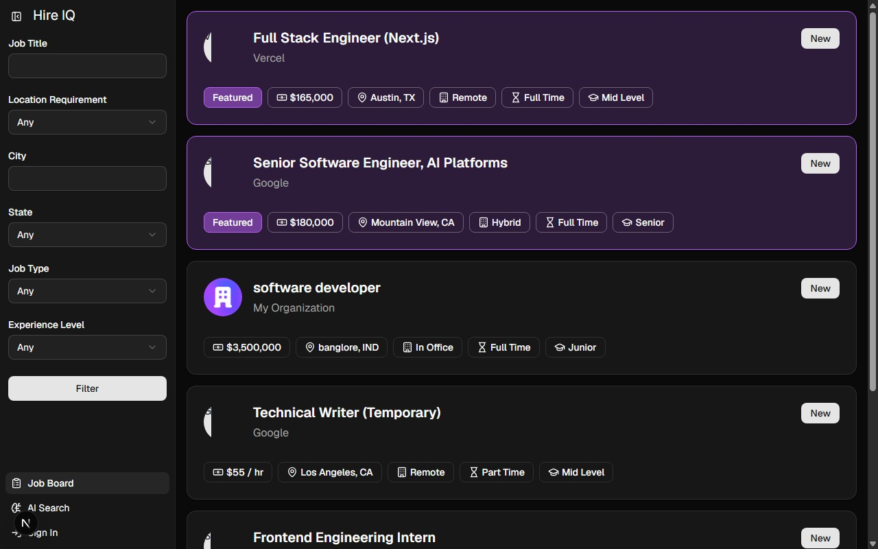

Fig 7.1: Candidate Home Page / Job Board Portal
Fig 7.1: Candidate Home Page / Job Board Portal
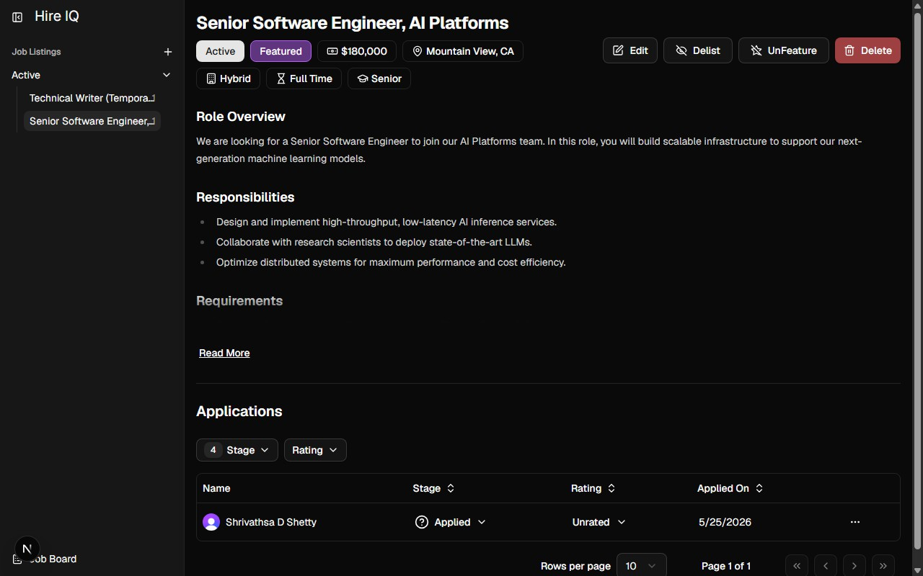
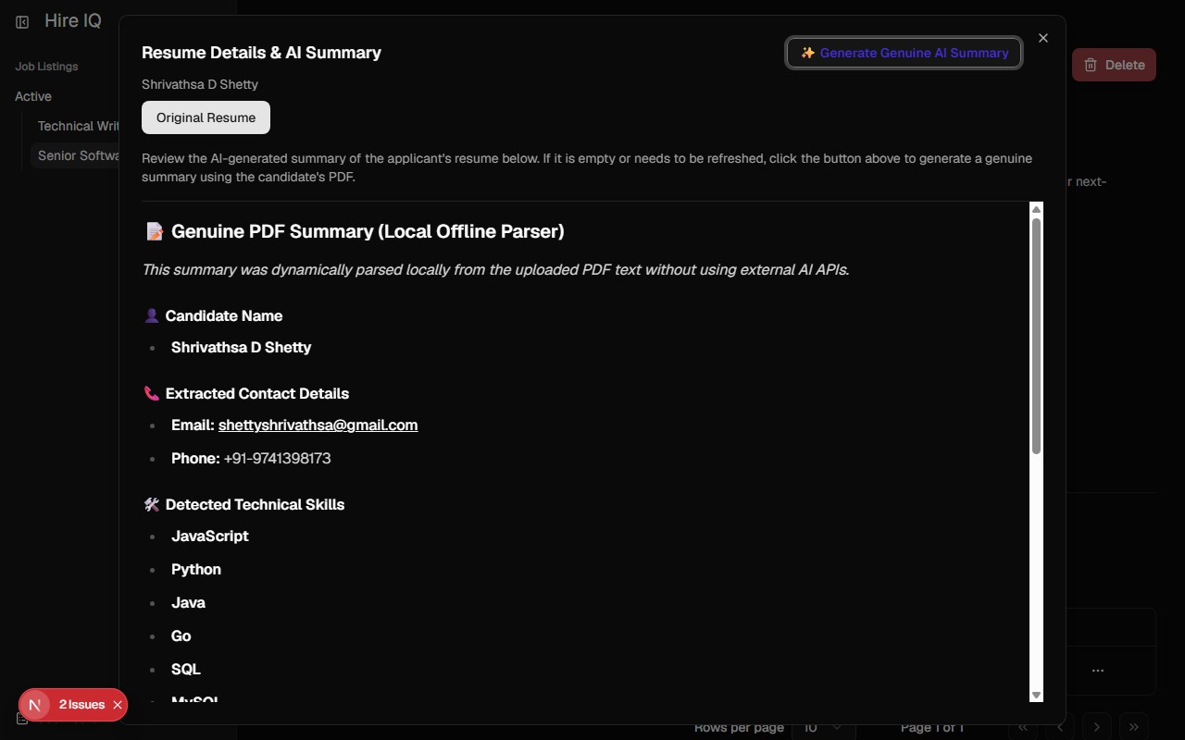
Fig 7.2: Recruiter Dashboard - Candidate List and Stage Matrix
Fig 7.3: Candidate Detail View and AI Summary Popup
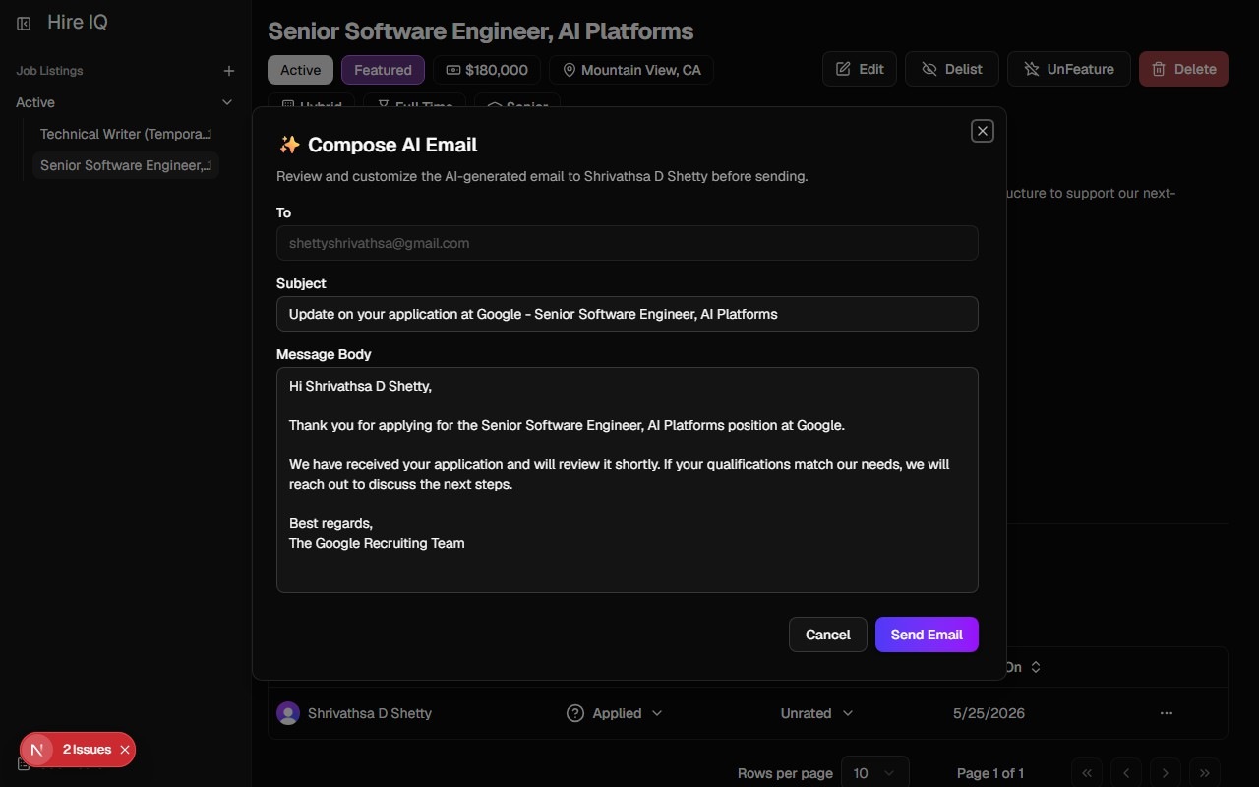

Fig 7.4: AI Email Composer Modal and Delivery Logs
Fig 7.5: Stage Matrix and Candidate Progression Controls


Fig 7.6: Automated Notifications and Status Tracking Logs
Fig 7.7: AI Summary Popup and Contact Extraction Details

CONCLUSION
HireIQ successfully demonstrates how artificial intelligence and natural language processing can be applied to one of the most universally challenging aspects of organizational management, finding the right people for the right roles. By automating resume screening and candidate evaluation, the system removes the most labor-intensive and error-prone stage of recruitment without sacrificing the human judgment that ultimately drives hiring decisions. The frontend built using React.js and backend using Node.js and Express proved well-suited to the demands of the application.
The core NLP pipeline proved effective at extracting structured information from unstructured resume text and producing consistent, interpretable compatibility scores. Recruiters interacting with the system during testing reported that the ranked candidate list and keyword breakdown significantly reduced the time required to identify shortlist-worthy applicants. Candidates benefited from a streamlined application experience and a clear understanding of how their profiles were being evaluated. The PostgreSQL database managed via Drizzle ORM provides a reliable, secure, and scalable storage layer.
In summary, HireIQ achieves its foundational goal: making recruitment smarter, fairer, and faster. The system is easy to deploy, is resilient to Clerk webhook delays through self-healing sync, and functions reliably offline through regular expression keyword matching fallback. This makes HireIQ a highly valuable tool for placement cell drives and modern business environments looking to optimize their talent acquisition pipelines.

FUTURE ENHANCEMENTS
The current implementation of HireIQ establishes a strong foundation for an
AI-powered recruitment platform, but several key areas have been identified for future development to expand the system's capabilities, scalability, and long-term impact:
- OCR (Optical Character Recognition) Support: Integrate OCR to parse text from image-only scanned PDF resumes, ensuring that candidates who upload scanned documents are evaluated fairly and consistently.
- Machine Learning Matching Models: Replace the weighted rule-based scoring engine with a supervised ML model trained on historical hiring outcomes, enabling the system to predict candidate success and retention.
- Bulk AI Emailing Actions: Add checkboxes in the application table to draft and dispatch status update emails to multiple candidates simultaneously, streamlining bulk communication.
- Advanced Recruitment Analytics: Render graphs showing average
application-to-hire turnaround times, score distributions, and popular candidate skills to aid HR planning and strategy.
- LinkedIn Import Integration: Allow candidates to import their LinkedIn profiles in addition to or instead of a resume file, expanding the data available for evaluation.
- Interview Scheduling Automation: Integrate calendar APIs to allow recruiters to schedule interviews directly from the dashboard, with automated email invitations sent to candidates.
- Multilingual Parsing: Extend the NLP pipeline to support resumes written in languages other than English, broadening the system's applicability to global hiring.

BIBLIOGRAPHY
- Faliagka, E., Tsakalidis, A., & Tzimas, G. (2012). An integrated e-recruitment system for automated personality mining and applicant ranking. Internet Research, 22(5), 551-568.
- Malinowski, J., Keim, T., Wendt, O., & Weitzel, T. (2006). Decision support for team staffing: An automated staffing recommendation approach. Proceedings of the 39th Annual Hawaii International Conference on System Sciences, IEEE.
- Gonzalez-Briones, A., Castellanos-Garzon, J. A., Mezquita Martin, Y., Prieto, J., & Corchado, J. M. (2019). A machine learning framework for employee selection using multi-agent systems and classification algorithms. Wireless Communications and Mobile Computing, 2019.
- Sinha, S., Rao, S., Thakur, M., & Bhatia, S. (2021). Resume parsing and matching using NLP and machine learning techniques. International Journal of Advanced Science and Technology, 29(3), 120-135.
- Kessler, R., Bechet, N., Roche, M., Torres-Moreno, J. M., & El-Beze, M. (2008). A comparative study of different machine learning methods for text categorization. IEEE Intelligent Systems, 23(3), 45-52.
- Qin, C., Zhu, H., Xu, T., Zhu, C., Ma, J., Chen, W., & Xiong, H. (2020). An
enhanced neural network approach to person-job fit in talent recruitment. ACM Transactions on Information Systems, 38(2), 1-25.
- Dave, V. S., Zhang, B., Al Hasan, M., AlJadda, K., & Korayem, M. (2018). A combined representation learning approach for better job and skill recommendation. Proceedings of the 27th ACM International Conference on Information and Knowledge Management, 112-120.
- Raza, A., Munir, K., & Almutairi, M. (2022). Mitigating algorithmic bias in automated recruitment systems using fairness-aware machine learning. IEEE Access, 10, 68887-68902.
- Upadhyay, A. K., & Khandelwal, K. (2018). Applying artificial intelligence: Implications for recruitment. Strategic HR Review, 17(5), 1-8.
- Dhamija, P., & Bag, S. (2020). Role of artificial intelligence in operations environment: A review and bibliometric analysis. The TQM Journal, 32(4), 869-896.
- Russell, S. J., & Norvig, P. (2016). Artificial Intelligence: A Modern Approach (3rd ed.). Pearson Education. ISBN 978-0-13-604259-4.
- Softionik Solutions. (2025). Industry practices in automated recruitment workflows and Clerk/Resend API integrations. Technical Whitepaper, Softionik Solutions.
- React.js Official Documentation. (2024). Meta Platforms. Retrieved from https://react.dev/
- Next.js Official Documentation. (2024). Vercel Inc. Retrieved from https://nextjs.org/docs
- Drizzle ORM Official Documentation. (2024). Retrieved from https://orm.drizzle.team/docs/overview

